Mike McCoy’s questions are in Red.

Nate Roth’s are in Blue.

Doug Drozd’s responses in **Purple.**

1. Segment costs by time period (Are costs Year of Expenditure, or current year (i.e. 2011 dollars)) **I’ve updated all costs below to give both 2013 dollars and YOE. Also pasted a graphic from our business plan.**

* Isn’t there an early “blended service” using the north of Fresno – North of Bakersfield section? This is an important clarification. It had been our understanding that the Fresno-Bakersfield rail section would be brought into service as early as 2019 improving the Fresno-Bakersfield times by ~45 min **Yes, the Merced to Fresno FCS will be complete by 2019 and will be available to improve service on the San Joaquin. However, since the Authority cannot operate with a subsidy, we would not be running those trains. So, this infrastructure *could* be used starting in 2019. As long as we make that clear, I think it’s fine to include it for illustrative purposes on the map.**
* FCS, Merced-Bakersfield -- $6Boperational in 2022 What is FCS? **FCS is the First Construction Segment – Merced to Bakersfield**
* Caltrain Modernization (SF to SJ) -- $1**.5**B, operational in 2019
* **Improved Palmdale to LA Corridor** -- $1B, operational TBD (ok to assume this is at least 2022 since HSR will be there by then? **Yes.)**
* IOS, Merced to SFV -- **$27.8B (2013) and $31.2 (YOE)**, operational in 2022 (Palmdale ? **No, the San Fernando Valley station location has yet to be set in stone, likely Burbank**)
* Bay to Basin, San Jose to SFV -- $42.5B **(2013) and $50.7(YOE)**, operational in 2026 (adding San Jose – Gilroy – Merced**? Correct, this is connecting San Jose, via Gilroy, to Merced and the IOS**)
* Phase I, Transbay Transit Center (SF) to Union Station (LA) -- **$54.9B (2013)** and $67.6B **(YOE)**, operational in 2028

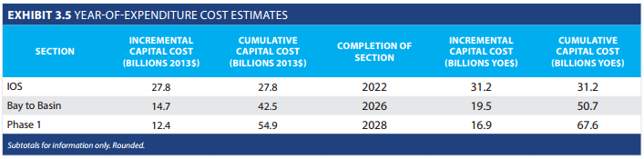

Please let me know if these are correct:

**FCS = First Construction Segment**, provides high-speed service Merced-Bakersfield in 2022 for a cost of $6B. **The FCS will not provide high-speed service until the IOS is complete, at which point we project we can begin operating HSR at an operating profit and meet the requirements of the bond act.**

**IOS = Initial Operating Segment**, provides high-speed service Merced to San Fernando Valley in 2022 at a cost of $27.8B. **Correct.**

**Bay to Basin**. Provides high-speed service San Jose to San Fernando Valley in 2026 at a cost of $42.5B. **Correct.**

**Phase I**, Provides high-speed service San Jose to Union Station, with SF (TTC) to SJ on Caltrain rail using HSR cars (i.e. single seat SF to Union Station). Operational in 2028 at a cost of $67.6B. **Correct, though I would say “using an electrified and modernized Caltrain corridor” rather than, “on Caltrain rail using HSR cars.”**

**Caltrain Modernization** will cost $1B, be operational in 2019, and includes the electrification and grade separation of Caltrain’s rail. **Correct, but it’s actually a $1.5B project. My bad.**

**Improved Metrolink** (is that the official name of the project? **No, rather it’s a series of projects outlined in the attached document. I was sloppy in referring to it as “improved Metrolink”. Rather, would call it improvements to the Palmdale-LAUS Corridor to prepare it for HSR**) will link Palmdale to LA (Union Station) in **????** for a cost of $1B.

Questions:

What is the significance of the FCS if both it and the IOS are beginning service in 2022? **As stated previously, the FCS can be used by Amtrak to improve service on the San Joaquins, but high-speed trains will not operate until 2022 when the IOS is complete.**

The IOS appears to be going far beyond Bakersfield and even Palmdale, all the way to the San Fernando Valley by 2022. Or, is the Palmdale to San Fernando Valley section being completed on the Improved Metrolink? **The IOS, when we project operations can commence without the need for an operating subsidy, will run high-speed trains from Merced to SFV in 2022. In the meantime, the SCAG MOU projects will be moving forward (grade separations, track improvements, safety, etc.) to better prepare the Palmdale-LAUS corridor for HSR service.**

Will the FCS be used at all prior to 2022? i.e. is part of the Amtrak San Joaquin switching to using it earlier? **See above. It can be used, but the decision is not up to us. We’re working to make sure the FCS becomes an asset to the state rail system upon its completion in 2019.**

The Transbay Transit Center to San Jose service will use HSR cars on Caltrain rail, with high-speed service beginning at San Jose and continuing to Union Station in LA.? **Once Phase 1 is operational in 2028, high-speed service will run from TTC to LAUS. In the Bay to Basin period, a rider leaving LAUS for TTC would: (1) take improved Metrolink to SFV station (say Burbank Airport); cross-platform transfer to HSR and ride on to San Jose; cross-platform transfer to electrified Caltrain and complete their journey to TTC.**

1. Jobs by segment by period

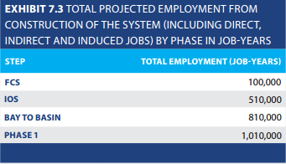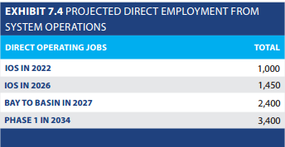

(IOS is Merced to Palmdale? **Merced to SFV** Sorry – I keep getting confused by the terms)

Are these numbers additive up to the Phase 1 total or are they independent over the years that each phase is developed? **Additive, so the IOS (510K) adds 410K job years on to the total generated by the FCS (100K)**)

Same question as Mike. Please clarify that Exhibit 7.3 is cumulative counting of job-years. i.e. the total of 510,000 for the IOS includes the 100,000 for the FCS. **See above.**

Above it was indicated that Phase 1 would be operational in 2028, that does not match with the Exhibit 7.4. Could you please clarify what the direct employment will be as of the launch of the full Phase 1 (and what year that will be if it is not correct above)? **2028 is when we project Phase I operations will begin, the 2034 numbers are after we have ramped up to maximum service. I can provide 2028 #’s if necessary, but our technical folks are jamming hard on the 2014 Business Plan (to be approved 4/10) and I don’t want o overload them.**

Do both operational segments continue to increase direct employment after their launch? That would explain the “lag” in the employment behind launch. **This is consistent with my understanding.**

1. Travel times and ticket cost station to station per time period (average)

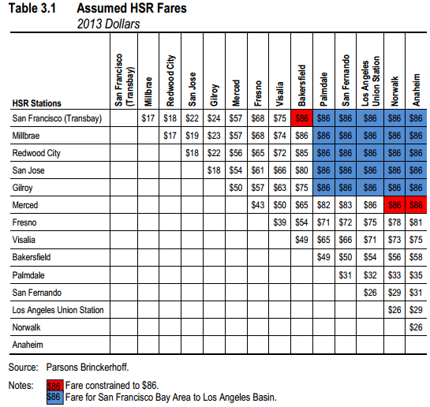

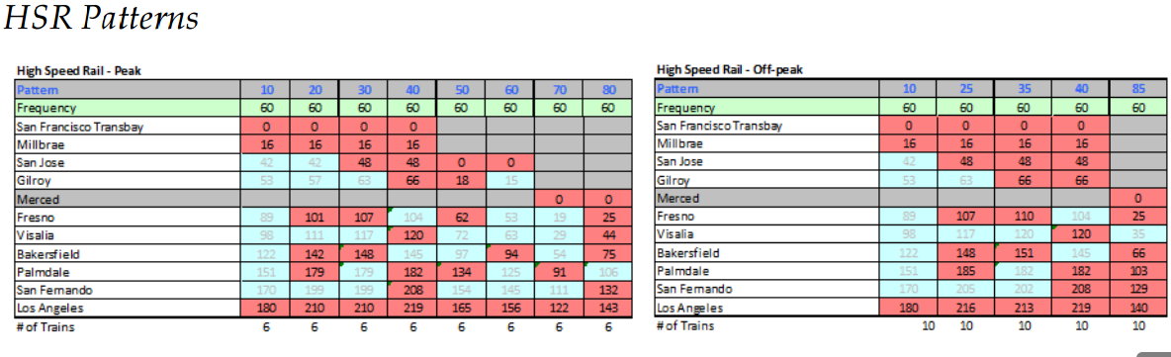

Will fares (station to station) for the IOS be the same as the fares for the full Phase 1? **For the Authority’s modeling purposes, we assume that fares will be the same between phases to be able to compare ridership and revenue outcomes.  Though please keep in mind that these figures are averages of projections of what HSR service *could* look like to allow us to make evaluations.  These charts are representative of mock service plans we have produced that are more detailed. However, since we’re many years from operations, we would describe all of these as illustrations of what service could look like under a private operator. Eventual fares and service patterns will be decided by the operator with oversight from the Authority. High-speed rail systems around the world, like airlines in the US, typically use yield management techniques to set fares so a non-refundable ticket purchased three months ahead of time would have a significantly lower fare than a first class ticket purchased at the last minute.**

What is the significance of the blue cells within the HSR patterns table?

**The blue squares are stations where that particular train is modeled not to stop. It shows the time that the train would be passing through that station.**

Is the Peak time chart saying that there will be one train of each pattern, each hour during the 6 hours of the peak period? This translates to 48 trains during the peak period? **Again, this is a somewhat generalized representation of what service could look like. Yes, your interpretation of the chart is correct.**

And how is the peak period defined?

**Three hours in the morning and three afternoon but varied by location and destinations (e.g. a peak time starting in Los Angeles and heading north may be different than a peak time starting in Fresno and heading south).**

Are there similar tables for the North-bound trains? **For ridership modeling purposes, travel times are assumed to be the same in both directions. Slight variations are considered in more depth in detailed service plans.**

1. Supportive transport and transit expenditures and jobs by service operator by time period

Northern California (since timeframe locally dependent we will depict consistently the same way across all 4 time phases if o.k.) I’d still like to attach dates to these if at all possible. Also, is there any information on what the “rest” of the cost is for each of these projects? i.e. Caltrain Electrification is $705M, but the total project is $1.5B. **All of these projects are fully funded. SB 1029 leveraged local/federal matching funds for all the projects. So for instance, the $705M in Prop 1A funds are being matched with local and federal funds to bring the project total to $1.5B. Can discuss further and work on getting estimated completion dates for some, if not all.**

* Caltrain Electrification -- $705M from SB 1029 to install an electric rail system that will replace diesel trains with high-speed rail. Total project cost $1.5B. How does this overlap with the Caltrain Modernization project to be completed at a cost of $1B in 2019? **The above has been corrected to say $1.5B.**
* BART Millbrae Station Track Improvements & Car Purchase -- $145M to lengthen track for cross platform connection to high-speed rail and to purchase new cars. Total $290M.
* SF MUNI Central Subway -- $61 mill to extend lightrail from 4th & King to downtown SF. Total investment of $1.6B
* Caltrans Capitol Corridor from Oakland to San Jose -- $47M for track improvements permitting increase in frequency. Total $248M.
* Caltrain PTC -- $42M for positive train control. Total $231M How is the total less than the amount for PTC? **Sorry, typo. Corrected to $42M**
* Caltrans San Joaquin Corridor, Merced to le Grand -- $41M for double track to increase service, reduce freight conflicts and increase safety.
* Sacramento RT Intermodal Facility -- $30M for relocation of light rail tracks, passenger platforms
* Caltrans Capitol Corridor from Sacramento to Roseville -- $16M for improvements to Roseville station to increase service frequency, reduce freight conflicts,and improve safety. $28M total.
* ACE Stockton Passenger Track Extension -- $11M to extend Stockton ACE platform to provide cross-platform transfer to Amtrak. $25M total.

Southern California

* SCAG MOU -- $500M for regional rail projects that improve local networks and facilitate HSR into Southern California. Total $1B.
* LA MTA Regional Rail Connector -- $115M for light rail connection between Metro lines to provide a one-seat ride from all stations to Union Station. $1.4B total.
* Metrolink New/Improved Locomotives -- $89M to repower and/or repurchase clean, efficient locomotives and passenger cars. $203M total.
* Metrolink PTC -- $35M for PTC on Metrolink, part of larger investment.
* SD MTS Blue Line Light Rail Improvements -- $58M for grade crossing, track and platform improvements. Improved reliability. $152M total.
* SD NCTD Advanced Signaling -- $17.8M for PTC on the Coaster serviced. $60M total.
* Should the Metrolink improvements extending service to Palmdale also be included here? Or is it not included to avoid the possibility of “double counting.” **See attachment to the email which fully details the three types of projects in Southern California: (1) SCAG MOU projects that will receive 1A funds; (2) SCAG MOU projects that will not receive 1A funds, but all parties have agreed to advocate in unison for; (3) “Connectivity projects” that have received funds from the CTC from the $950M set aside in Prop 1A for improvements to connect to HSR.**

1. Alternative highway and air construction costs by time period (or total ok)
2. October 2011 CTC Needs Assessment -- $183B in capital expansion needs by 2020 (not including HSR) [www.catc.ca.gov/reports/2012%20Reports/Trans_Needs_Assessment_corrected_01172012.pdf](http://www.catc.ca.gov/reports/2012%20Reports/Trans_Needs_Assessment_corrected_01172012.pdf)
3. Independent, non-partisan *Think Long Committee for California* -- $550B over next decade

<http://berggruen.org/uploaded_files/topic/pdf/62/blueprint_to_renew_ca.pdf>

1. American Society of Civil Engineers -- $365B *above* existing funding levels over next decade

[www.ascecareportcard.org](http://www.ascecareportcard.org)

1. The Authority has not conducted its own needs assessment for transportation. However, a comparison of costs of equivalent capacity provided through different modes of transportation is found here: <http://www.hsr.ca.gov/docs/about/business_plans/BPlan_2012CompareEquivalentCapacity.pdf>

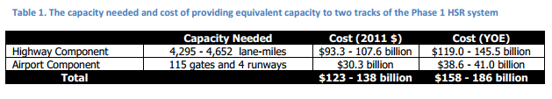

1. Studies done to substantiate GHG claims. Other supportive.

Here’s our study: <http://www.hsr.ca.gov/docs/programs/green_practices/HSR_Reducing_CA_GHG_Emissions_2013.pdf>

From Meg Cederoth:

If GHG, UC Berkeley is going to be under contract soon adding HSR to their Cool California tool, which will allow a user to toggle on HSR as a transport option within their mapping, and view the resulting deduction in their carbon foot print. We will check with UCB on timeline. We could link storymap to their site.

Until then, HSR emissions are a really a statewide feature, corresponding to the addition of segments of the project (IOS, BtB, phase 1)

AQ emissions can be dissaggregated to different airsheds based on VMT reduction in a given region. The discrete segment EIRs will have that data.